# 

Wireframe Documentation

Analysing Swiggy: Bangalore delivery outlet data

[AUTHOR NAME]

[AUTHOR NAME]

# Contents

1. Dashboard.................................................................................................................. 3

2. Cards.......................................................................................................................... 4

3. Slicers …………………………………………………………........................................................... 5

4. Bar chart of shop name by Locations........................................................................ 6

# 5. Bar chart of count of cuisine by location ……….......................................................................7

6. Matrix chart ……………………………………........................................................................ 8

7. Pie chart count of cuisines........................................................................................ 9

# Dashboard

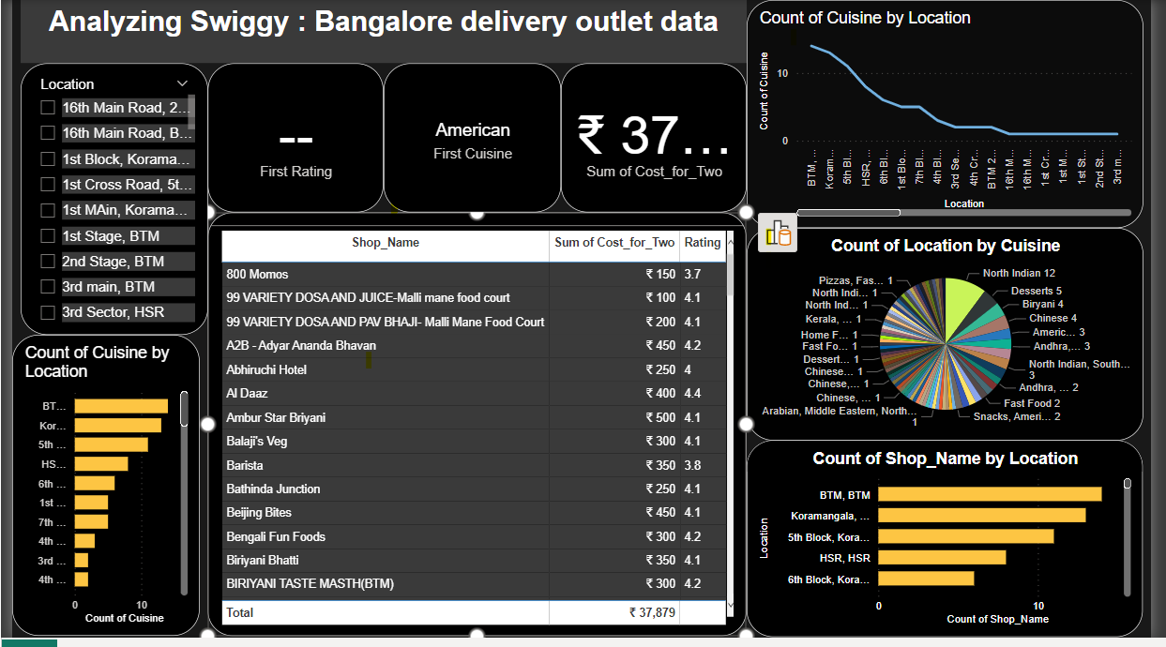

# 2. Cards

The card that shows Ratings, Locations and Areas

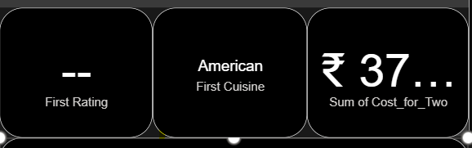

# 3. Slicers

Shows list of locations in Bangalore.

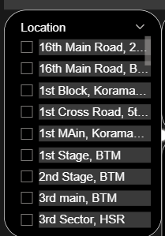

# 4. Bar chart of shop name by Locations.

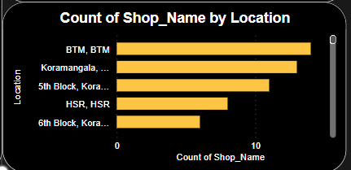

# 5. Bar chart of count of cuisine by location

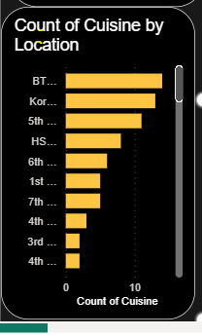

# 6. Matrix which show hotel name, Rating of hotels and Cost for two prices.

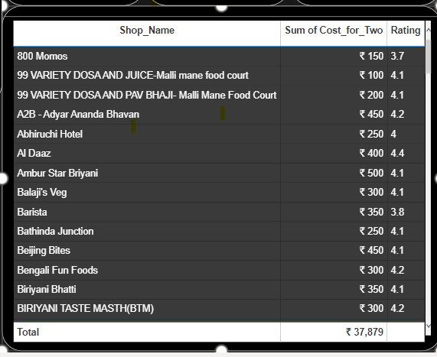

# 7. Pie chart which count of cuisine by location

